APPLICATION FORM FOR PARTICIPATION AT THE EXHIBITION under nr. __ dated „___”___________2017

Company name:
Index, address: |  |  |  |  |  |  |  | Phone:
Legal address: |  |  |  |  |  |  |  | Fax:
 |  |  |  |  |  |  |  | E-mail:
Denomination |  |  |  |  |  |  |  | Price  (VAT including) |  |  | Quantity |  |  |  | Total, euro  (VAT including)
Registration fee |  |  |  |  |  |  |  | 85 Euro
Equipped indoor area per 1 m2 |  |  |  |  |  |  |  | 70 Euro
Unequipped indoor area per 1 m2 |  |  |  |  |  |  |  | 50 Euro
Unequipped outdoor area 1 m2 |  |  |  |  |  |  |  | 20 Euro
Additional services
Participation on Internet-portal www.allexpo.md
(indicate article according to the price-list)
Extra-charges for the stand”s type
Total:
Stand”s type
A Standard □  (1 side open)  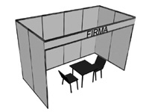 |  |  |  | B Corner □  +10 %  (2 sides open)  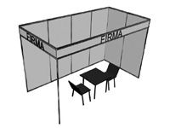 |  |  |  |  | C Head □  +15%  (3 sides open)  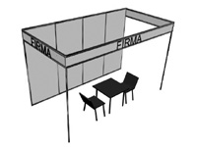 |  |  |  |  | D Built apart □  +20%  (4 sides open)  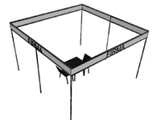
Inscription on fascia board

Attention: Exhibition area is considered reserved just after 30% advance payment out of the cost of the total area reserved, as well as after 100% payment settlement of registration fee.
“Exhibitor” fills out the Application form and sends to “Organizer”. After the ordered exhibition area is agreed, “Exhibitor” sends Agreement and settles payment for participation at the exhibition.

Exhibitor  Director ________________/____________________/  signature  Stamp  Date ___/ ____/ 20___ | Organizer  Executive Director IEC „MOLDEXPO” SA ______________/ Valentin Cainarean/  Stamp  Date ___/ ____/ 20___

C.I.E. "MOLDEXPO" SA
E-mail: rodica@moldexpo.md

