……………………………………………….………………….. September 21 – 24, 2017

Application form for participation in the exhibition under № __ dated „___”___________2017

Company name:
Index, address: |  |  |  |  |  |  |  |  | Phone:
Legal address: |  |  |  |  |  |  |  |  | Fax
 |  |  |  |  |  |  |  |  | E-mail:
Denomination |  |  |  |  |  |  |  |  | Price, Euro (VAT including) |  |  | Quantity |  |  | Sum, Euro (VAT including)
Registration fee |  |  |  |  |  |  |  |  | 130
Equipped indoor area per 1 m2 |  |  |  |  |  |  |  |  | 120 Euro
Unequipped indoor area per 1 m2 |  |  |  |  |  |  |  |  | 110 Euro
Outdoor exhibition area per 1 m2 |  |  |  |  |  |  |  |  | 50 Euro
Advertising in the official catalogue
Additional services
Participation on Internet-portal www.allexpo.md
Extra-charges for the stand’s type
Total:
Stand’s type
A Standard □  (1 side open)  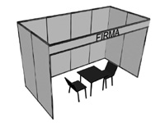 |  |  |  | B Corner □  +10 %  (2 sides open)  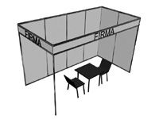 |  |  |  | C Head □  +15%  (3 sides open)  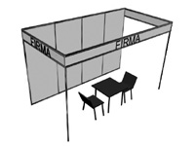 |  |  |  |  |  | D Built apart □  +20%  ( 4 sides open)  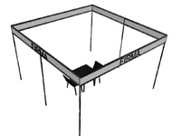
Inscription on fascia board

Attention: Exhibition area is considered reserved just after 30% advance payment out of the cost of the total area reserved, as well as after 100% payment settlement of registration“Participant” fills out the Application form and sends to “Organizer”. After the ordered exhibition area is agreed, “Participant” sends Agreement and settles payment for participation

Exhibitor  Director ________________/____________________/  Stamp  Date ___/ ____/ 20___ | Organizer  Executive Director I.E.C "MOLDEXPO" S.A  _____________/ Valentin Cainarean /  Stamp  Date ___/ ____/ 20___

IEC "MOLDEXPO" JSC
E-mail: ivanov@moldexpo.md

